1)date



2)cal

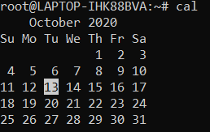

cal -m1

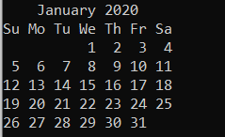

Cal 2022 -m1

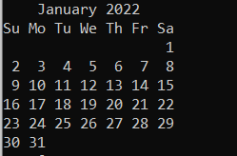

3)bc



Q2)

Create three directory a b and c and create a.txt,b.txt and c.txt

in each directory respectively and then copy c directory into the a.





Create alias of ls -lh command to your name.



Q3)

Create five files file1.txt , file2.txt ,file3.txt file4.txt and

file5.txt with some text inside it. Search for 's' character

inside all the files using grep command.

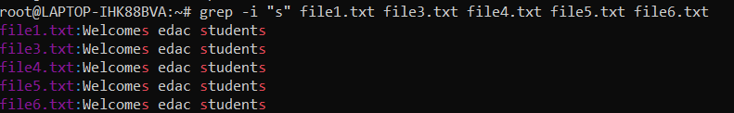

Create file.txt using cat and edit that using nano editor

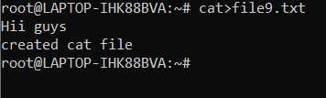

Create 5 empty files using touch command

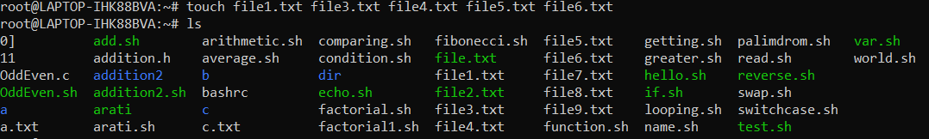

Remove previously created directory a , b and c

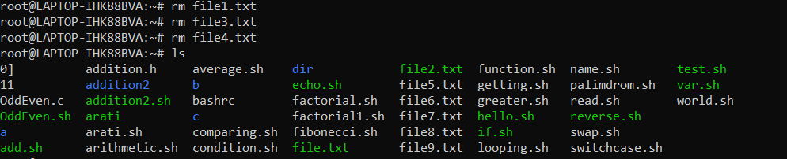

Q4)Create a file with some content using vi editor

Display the file using cat command



Display line numbers along with content



Combine multiple files using cat command

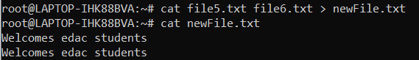

Q5)

display files row wise, column wise, 1 per row

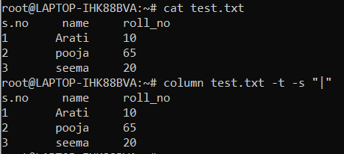

sort the files in ascending, descending order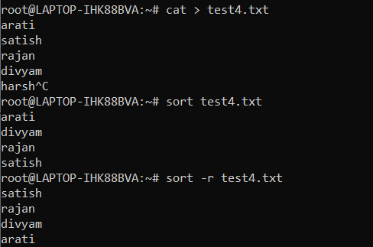

Create some hidden files and sub directories and display them using “ls -a”

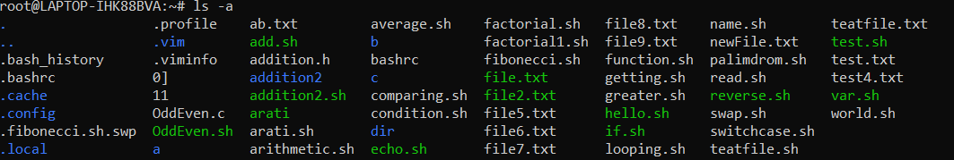

Change time stamp of some files and directories using touch command and display the files using ls -t ls -rt

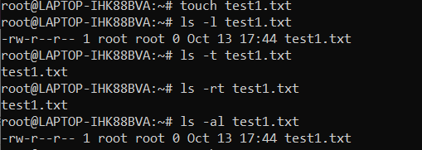

Recursive display contents of your home directory.

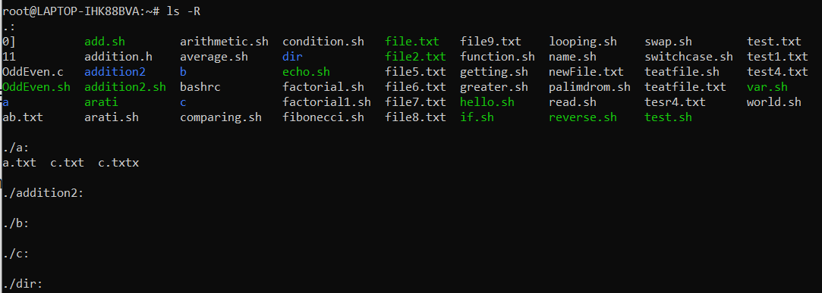

display all attributes of files and directories using ls -l

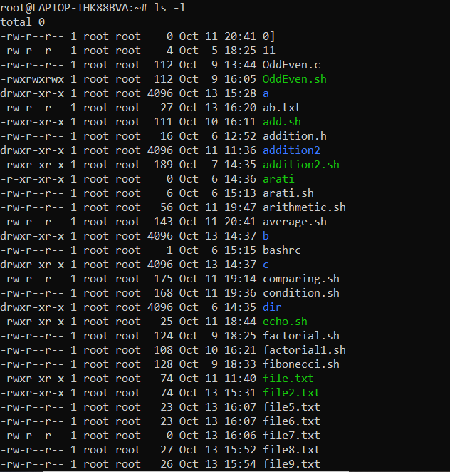

display attributes of a directory using ls -ld



Q1) Create directory of your name and then create 4 files inside it named

a.txt, b.txt, c.txt and d.sh. And change the directory permission to

only user and also files permission to only user such that

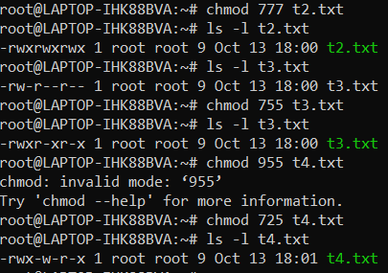

user can read and write the file a.txt and b.txt

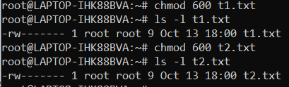

user can write the file c.txt



user can exectuable the file d.sh. Make

Contents of file d.sh:

#/bin/sh

ls -lh

